Alcohol consumption is universal, and this short report will investigate if there is a connection between happiness and alcohol consumption. The aims of this research were to investigate how happiness is related to beer consumption followed by exploring if the addition of wine can better predict drinking beer. It was hypothesised that there will be a negative correlation between happiness and drinking beer. The more beer consumed, the less happy an individual and country is overall.

**Method**

Dataset was collected from Kaggle in a CSV format and Python was used to analyse the data. Pandas, Matplotlib were the main packages used for this analysis. A simple linear regression was used as model 1 with the independent variable as happiness and dependent variable beer consumption per capita across countries worldwide. A multiple linear regression was used as model 2 with independent variables as happiness and wine consumption while the dependent variable was beer consumption There were 85 samples in the training set and 37 in the testing set

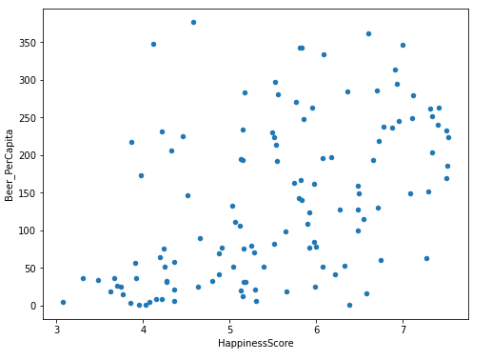 **Results**

*Figure 2.* Scatterplot of Happiness and beer consumption worldwide

As can be seen from figure 1, there is moderate positive linear correlation (0.49) between happiness and beer consumption. This warranted further exploration of using a linear regression model with happiness as a predictor to predict beer consumption.

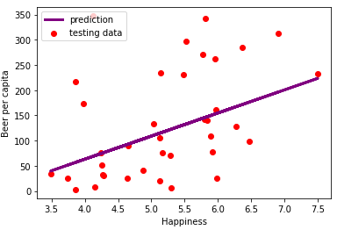

*Figure 2:* Scatter plot showing the testing data set (actual values) vs the predicted

line of best fit

As can be seen from figure 2, The mean-squared error and root mean-squared error were 9143 and 95.61 respectively. The model explained 16% of the variability in the data. When wine was added in the model, the mean squared error and root mean-squared error were 7524 and 86.74 respectively

**Discussion**

Contrary to the hypothesis that happiness would decrease with increased beer consumption, there was in fact a moderate positive relationship between happiness and beer consumption worldwide. When comparing the simple and multiple linear regression models, the multiple linear regression model more accurately predicted beer consumption based on explaining more of the total variance than model 1 and had a smaller RMSE. Further directions could be to combine wine and beer consumption together to represent alcohol consumption and possibly spirit alcohol as well with happiness as the independent variable. Overall, there tends to be slight positive relationship with drinking beer and reported happiness.